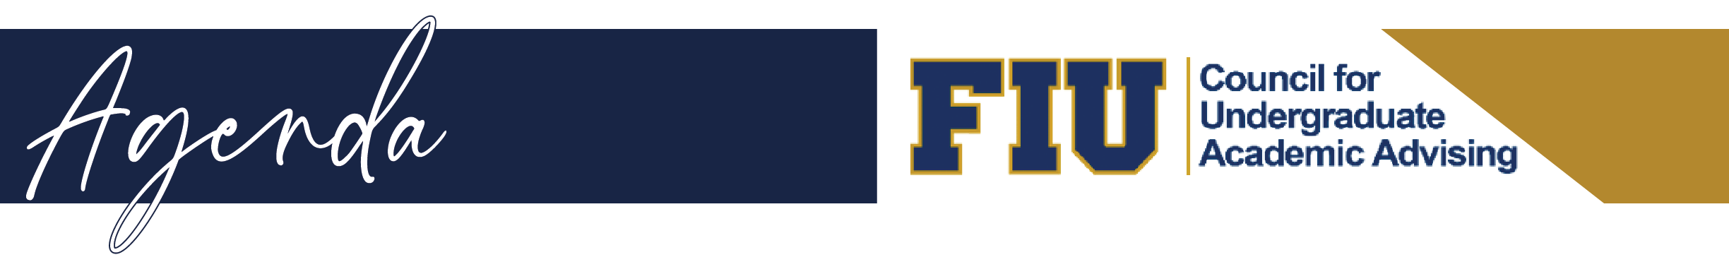
Dec. 14, 2022
Location: SASC 430 and https://fiu.zoom.us/j/9684835389

CUAA
- Professional Advisors Spring 2023 Conference - Joselyn Naranjo
- Advisor DRIVE – Alina Dominguez
- Peak season advising and university closure best practices

OFP
- Updates
Registrars
End of Term Processing
Tuesday, 12/13 - Online grade change link inactivated
Thursday, 12/15 - Fall 2022 grades post
- ERC List to College Advisors will be available at noon
- Friday, 12/16 - Dismissal notifications
- Run NC grade process
- Monday, 12/19 - Online grade change link will be available
- PERC List is due at noon
- Begin posting of Fall 2022 degrees
- Thursday, 12/22 - Send posted Fall 2022 degree(s) communication
- Tuesday, 01/10/2023 - Deadline to submit Fall 2022 dismissal appeals
*Reminder that all Fall degree requirements must be completed by the last date of the term time frame. Otherwise, the graduation has to be posted the following term.
Term | Description | Begin Date | End Date | Degree Conferral Date | Term Description | Term Time Frame Date
1228 | Fall 2022 | 08/22/2022 | 12/10/2022 | 12/17/2022 | Fall | 12/11/2022 - 01/08/2023

New unofficial Transcript view for students and staff in PantherSoft
Will be live tomorrow (Thursday) night. Manual attached.

OneStop
- Updates – Spring Enrollment Cancellation Timeline

OASIS
- Updates and professional development opportunities – Maria Walker

Open Floor

